**CONDITIONAL STATEMENTS**

**1. Write a Shell Script to find maximum between two numbers.**

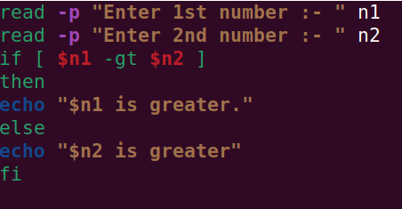

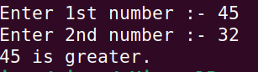

**2. Write a Shell Script to find maximum between three numbers.**

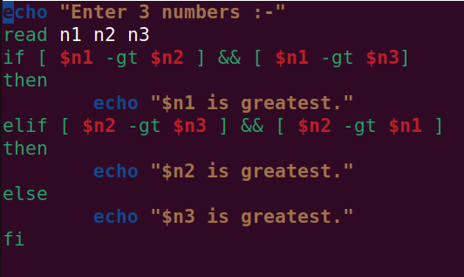

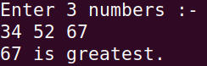

**3. Write a Shell Script to check whether a number is negative, positive or zero.**

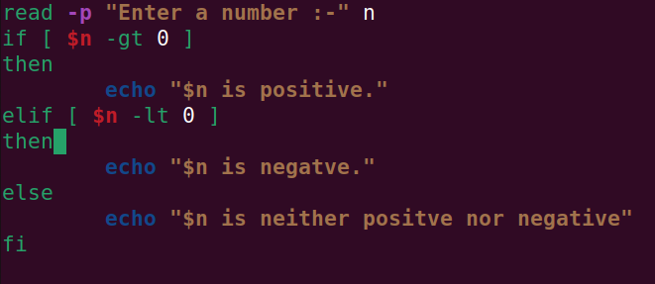

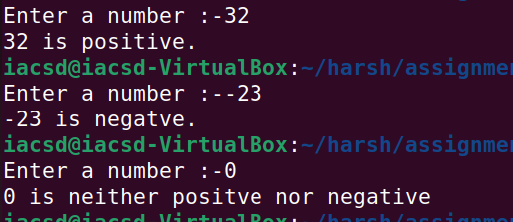

**4. Write a Shell Script to check whether a number is divisible by 5 and 11 or not.**

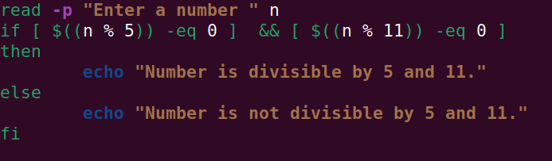

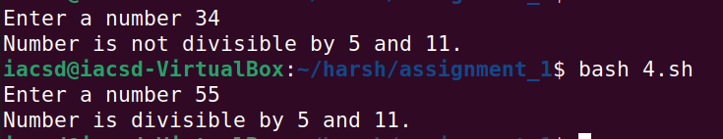

**5. Write a Shell Script to check whether a number is even or odd.**

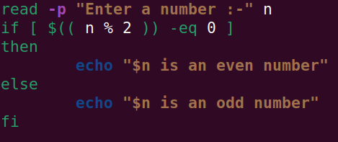

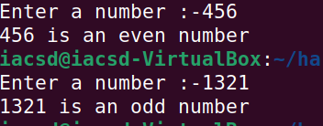

**6. Write a Shell Script to check whether a year is leap year or not.**

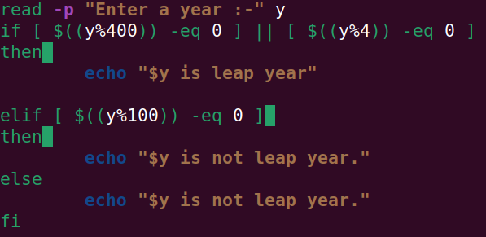

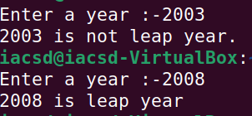

**7. Shell Script to print number between 1 to 10 in character format using switch-case.**

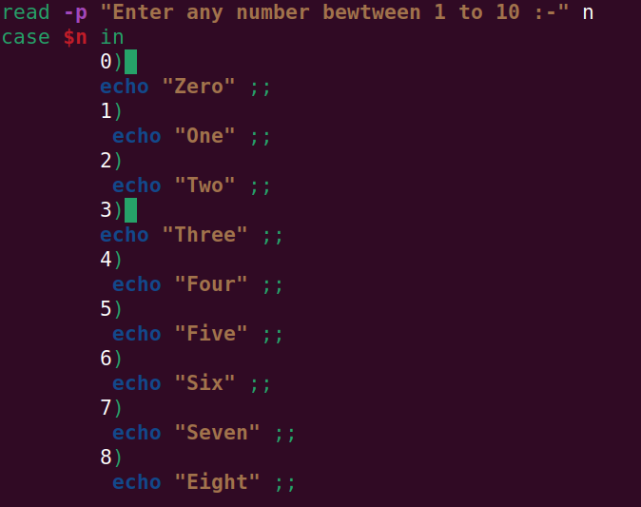



**8. Shell Script to accept id fro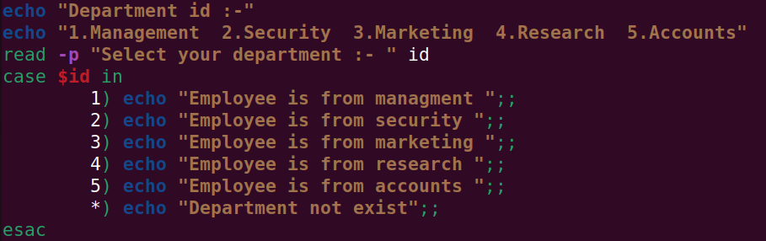m user to confirm department using switch-case.**

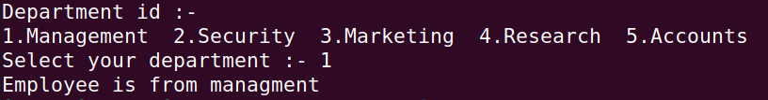

**9. Shell Script to check password is correct or incorrect using switch-case.**

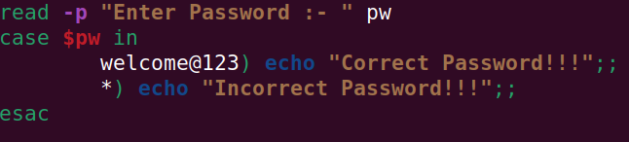

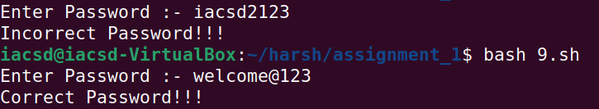

**10. Shell Script to print day of week using switch-case.**

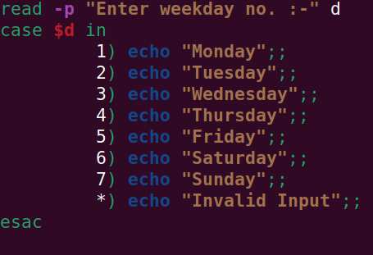

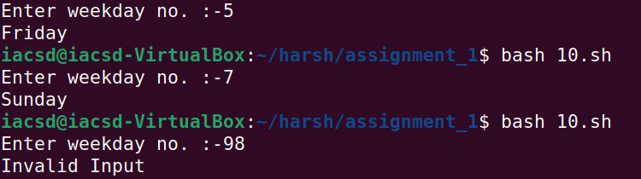

**11. Shell Script to create calculator using switch-case.**

